2025 CMDFA

Combined IMPACT – Student conference

National Conference

SPONSORSHIP PROSPECTUS

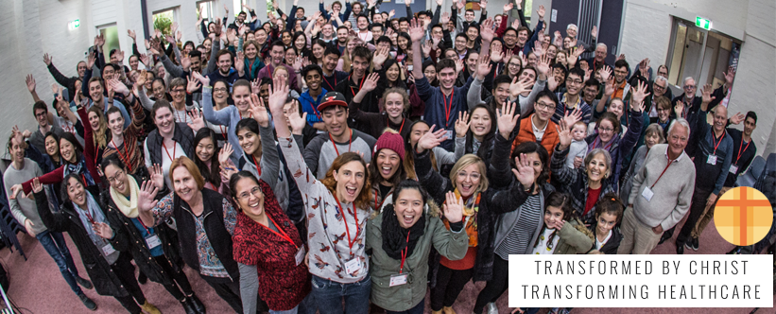

Introduction to CMDFA

The Christian Medical and Dental Fellowship of Australia (CMDFA) comprises more than 600 Christian doctors, dentists, medical and dental students around Australia.

CMDFA is also working in alliance with the Nurses Christian Fellowship of Australia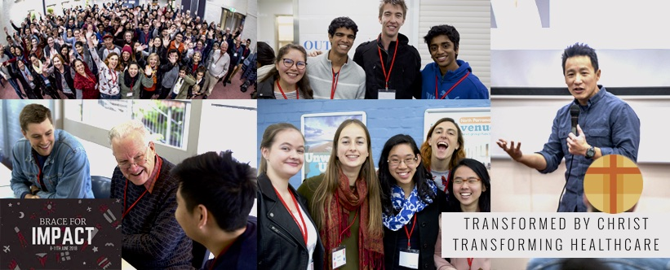, HealthServe and other allied healthcare professionals.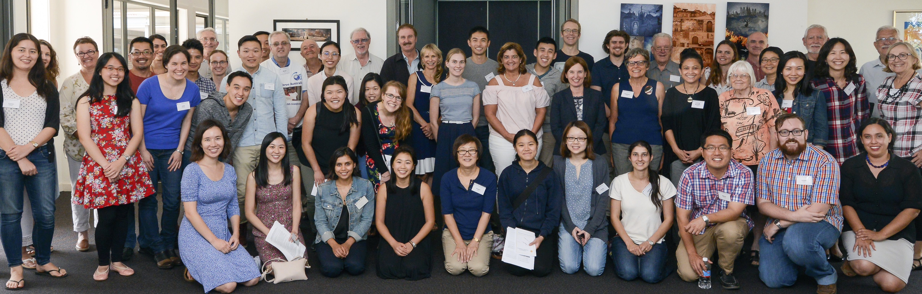

CMDFA seeks to meet its Mission “Transformed by Christ, Transforming Healthcare” by running programmes and activities which include:

* Representing Christian values on medical issues such as euthanasia to professional medical bodies, State and Federal legislatures.
* Supporting our (50) Missionary members while serving overseas.
* Our Bi-annual National Conference for all our members
* Our annual Vision conference for student leaders current and potential
* The annual IMPACT conference for Students, Recent Graduates and Mentors
* Our publication Luke’s Journal published 2-3 times a year -free to all members
* State and regional fellowship bodies running local activities across the year
* Hospital prayer and fellowship groups across the country
* Student fellowship activities on medical and dental campuses across Australia.

These activities and programmes encourage Christian doctors and dentists to serve and honour God in their professional practice and strengthen our students in their faith. We do this through providing avenues for sharing, discussion, evangelism, and supporting cross-cultural mission throughout the year.

2025 Combined IMPACT and National Conference

CMDFA is holding its first face to face student conference since 2019.

25 Apr - 28 Apr 2024

In 2025 the combined conference is being held at the Women’s College

University of Queensland College Road  
St. Lucia QLD 4067  
AUSTRALIA



We are aiming for an attendance of over 200 Medical and dental practitioners and students from around Australia as well as mentors and other fellowship members.

The theme this year will be - “Hope in Christ: Setting our Eye on eternity”. our prayer is that delegates would be strengthened in their faith, challenged by Christ’s call and seek to serve Him in every area of life.

The organising committee are currently finalising the keynote speakers and workshops.

Our keynote speaker will be:

**Richard Chin**is married to Jeanette and the father of 4 young adult children. He serves as the National Director of the Australian Fellowship of Evangelical Students (AFES) and is based in Canberra where he also serves as a member of Crossroads Christian Church. He is the author of [*Captivated by Christ, and How to Read the Bible Better*](https://matthiasmedia.com.au/products/captivated-by-christ?_pos=1&_sid=527ddca4b&_ss=r).

Sponsorship Opportunities

Principal Sponsor

### Proposed amount: $2500:Sponsorship benefits:

* Full page (A5 size, portrait), high quality advertisement in IMPACT conference participant booklet
* Organisation logo on home page of IMPACT Conference website section in the CMDFA website. At this early stage we would also include sponsors details in our pre conference communications to all members.
* Banner at registration desk
* Stall alongside for duration of conference to display information and provides the opportunity for members of the sponsor organisation to talk to attendees and inform them of the work of the sponsor organisation.
* Acknowledgement of the sponsor organisation as Principal Sponsor of our event in list of sponsors both on our website and projected on the screen in the main auditorium between sessions
* Two opportunites for a representative from the organisation to speak for 5 minutes immediately prior to a plenary session, AND to have a video, of not more than 5 minutes duration, played on the main screen in the main auditorium at this time.
* At this early stage it is possible that opportunities to run a workshop or to be a speaker could be negotiated.

Major Sponsor

**Proposed amount: $2000: Sponsorship benefits:**

* Half page (A6 size, landscape), high quality advertisement in conference participant booklet
* Organisation logo on sponsorship page of IMPACT website page.
* Acknowledgement of your organisation as Major Sponsor of our event in list of sponsors projected on the screen in the main auditorium between sessions. At this early stage we would also include sponsor details in our pre communication to all members.
* Opportunity for a stall and banner for the duration of the conference.
* Opportunity EITHER for a representative from the organisation to speak for 5 minutes immediately prior to a plenary session, OR to have a video, of not more than 5 minutes duration, played on the main screen in the main auditorium at this time

Minor Sponsor

**Proposed amount: $750: Sponsorship benefits:**

* Half page (A7 size, portrait), high quality advertisement in conference participant booklet
* Organisation logo on sponsorship page of National website
* Acknowledgement of sponsorship at the start and end of the conference
* Opportunity to have a stall and banner at the conference to be able to engage with conference delegates.

Sponsorship Application Form

I am interested in taking

* + - A principal Sponsorship $2,500.00
    - A Major Sponsorship $2,000.00
    - A Minor Sponsorship $ 750.00

Organisation name:

Title:

Christian Name:

Surname:

Street Name

Suburb/City

State

Payment Details”

Credit card

Bank transfer

Please send me the CMDFA sponsorship agreement form for signature