2026

IMPACT Student conference
Perth, WA
God the Great Physician
24-27 April

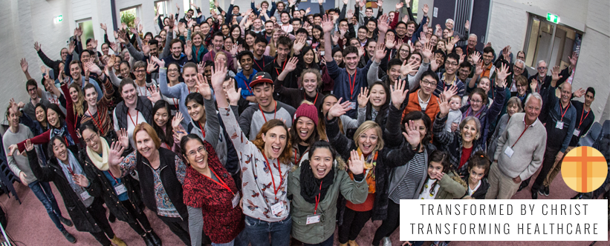
SPONSORSHIP PROSPECTUS

Introduction to CMDFA

The Christian Medical and Dental Fellowship of Australia (CMDFA) is a network of almost 800 Christian doctors, dentists, allied health professionals and students around Australia.

CMDFA seeks to inspire and mobilise its student and graduate members to live out the Gospel in all of their professional and personal lives.

2026 IMPACT Conference

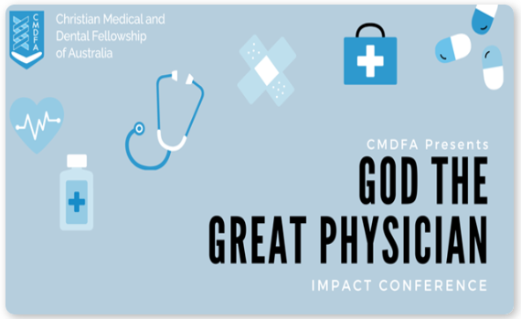

We are expecting an attendance of over 100 medical and dental students and recent graduates from around Australia. Graduate mentors numbering more than 10 are expected.

The Conference will be held from 24-27 Apr 2026, and will be held in Perth, Australia

Sponsorship Opportunities

GOLD Package

$2200 (GST Inclusive)
- Full page (A5 size, portrait), advertisement in IMPACT conference participant booklet
- Acknowledgement of the sponsor organisation as GOLD Sponsor of our event in list of sponsors projected on the screen in the main auditorium between sessions
- TWO opportunites for a representative from the organisation to speak for 3 minutes immediately prior to a plenary session, AND to have a video, of not more than 3 minutes duration, played on the main screen in the main auditorium at this time or a separate time determined by the conference organisers
- Banner at registration desk
- Stall in the foyer for duration of conference

SILVER Package
$1,250 (GST Inclusive)
- Half page (A6 size, landscape), advertisement in conference participant booklet
- Acknowledgement of your organisation as SILVER Sponsor of our event in list of sponsors projected on the screen in the main auditorium between sessions.
- Opportunity EITHER for a representative from the organisation to speak for 3 minutes immediately prior to a plenary session, OR to have a video, of not more than 3 minutes duration, played on the main screen in the main auditorium at this time
- Stall in the foyer for duration of conference

Bronze Package
$750 (GST Inclusive)
- Quarter page (A7 size, portrait), high quality advertisement in conference participant booklet
- Acknowledgement of sponsorship at the start and end of the conference
- Stall in the foyer for duration of conference

SPONSORSHIP APPLICATION

Organisation
Contact Person Name
Mobile
Email

I would like to apply for:
GOLD $2,200 GST Inclusive ☐
SILVER $1,250 GST Inclusive ☐
BRONZE $750 GST Inclusive ☐

On acceptance of your application, you will be issued an invoice. Once invoice is paid, your sponsorship will be confirmed.

Email this Form to:

<treasurer@cmdfa.org.au>

Dr James Wei, MBBS, FRACGP
CMDFA National Treasurer

